Jo’s Quirky Quilt block- No pattern needed
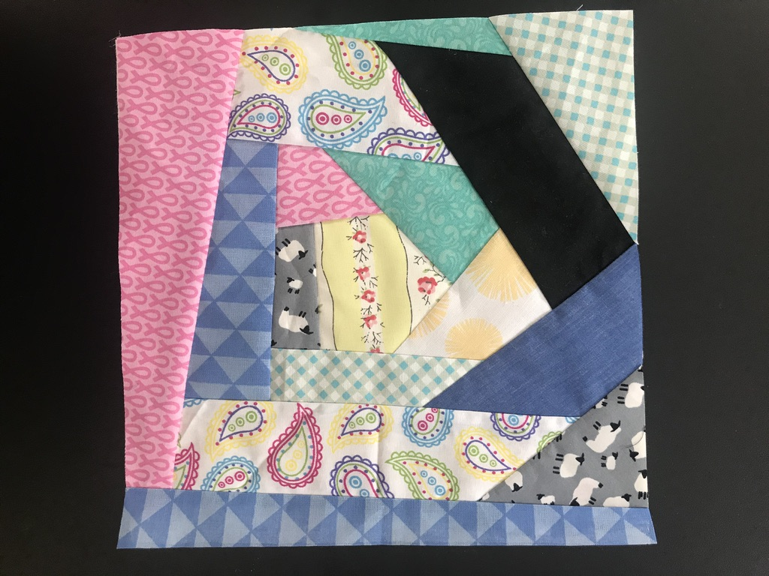
It is going to be very “Quirky”—none of my fabrics look good together and are too small to use for anything else.
When the blocks are sewn together to make a quilt, they will work, no idea how or why, but they do and my scraps will have become something useful and Quirky
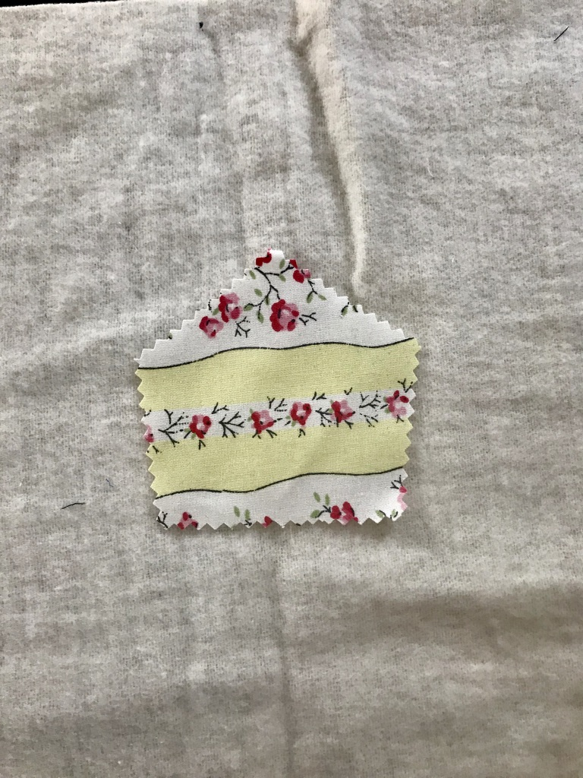
1. Cut an old duvet cover/sheet into squares for the base. Size doesn’t matter so long as they are all the same. (Mine are 10.5 inches)
2. Placed a rough 5 sided scrap of interesting fabric in the middle of one square.
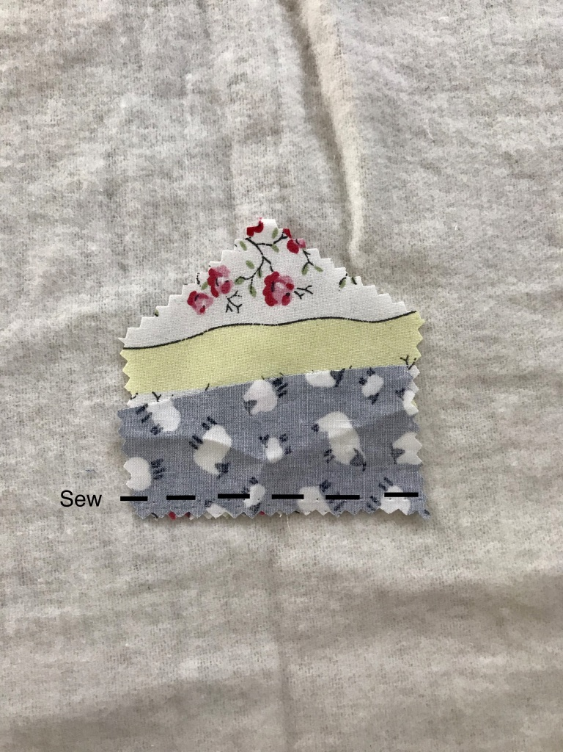
3. I added another scrap, face down, and stitched along one side.
4. Flipped that over and pressed it open.
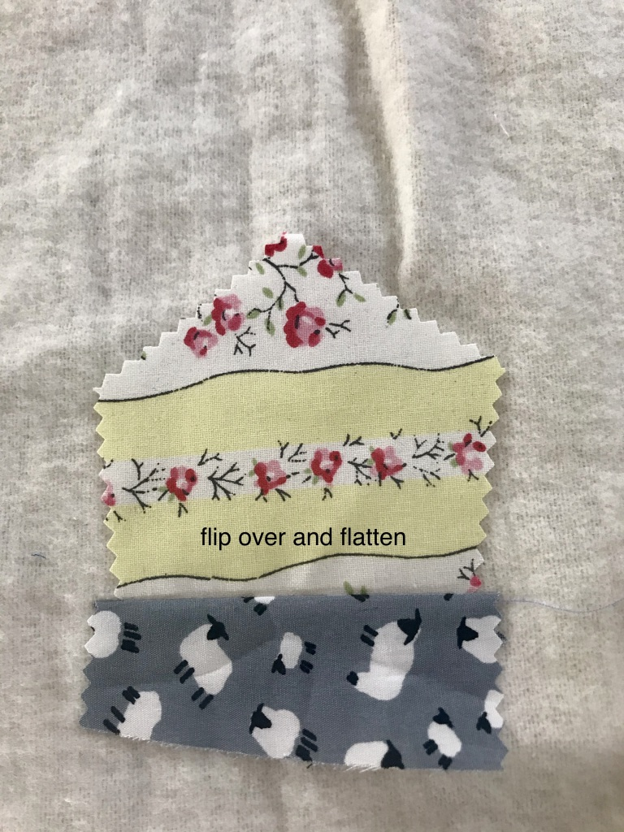
5. Working round the first shape in a clockwise direction, I added another scrap face down and stitched along that line.
6. Continued until the whole square was covered. I then pressed and trimmed the edges to 10’ square. (see first photo)
This should take around 20 minutes to complete a 10.5 inch block.
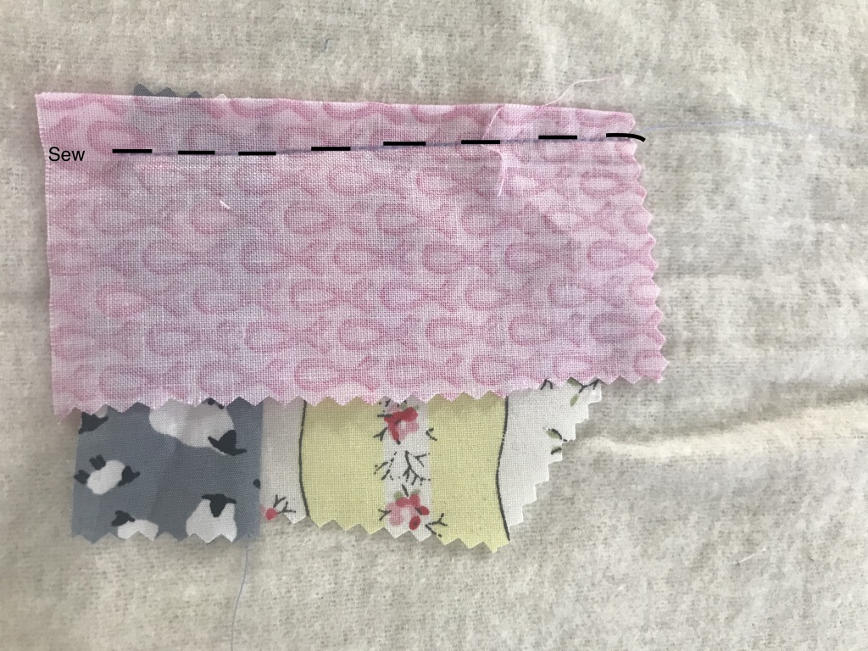
WARNING: This is very addictive, but is wonderful for your mental health and freeing up space to buy more fabric!

